Appendix 1 On-Site Response Plan for Laboratory Chemical Spills

- Accident Description
While teaching or in scientific research, if chemicals are improperly handled or stored, or if the facilities used for handling and storage malfunction, some chemicals may leak and come into contact with people, causing personal injury, or may be released into the environment. For example, spilled material may be discharged into the sewer, may leak directly into soil or surface water, or may be released into the atmosphere and have an impact.
In most cases, laboratory chemical spills involve small quantities, and if effective response are taken, the impacts are limited. However, if the spill involves chemicals that are highly flammable, strongly corrosive, highly extremely toxic, it may result in more serious consequences, which mainly include:
- Highly flammable chemicals
- Flammable liquids, Category 1: flash point below 23°C and initial boiling point not exceeding 35°C, e.g., diethyl ether, petroleum ether, etc.
- Flammable solids and pyrophoric solids, liquids, or mixtures, Category 1: e.g., white phosphorus, sodium borohydride, potassium borohydride, lithium, etc.
- Highly toxic or extremely toxic chemicals
- Highly toxic chemicals: refer to the List of Highly Toxic Substances, e.g., acrylamide, benzene, etc.
- Extremely toxic chemicals: refer to the List of Hazardous Chemicals, e.g., chlorine, etc.
- Chemicals with acute toxicity / specific target organ toxicity, Category 1 or Category 2 (fatal if swallowed, in contact with skin, or if inhaled), e.g., chloroform, etc.
- Strong corrosives
- Skin corrosion: results in irreversible damage to the skin; that is, visible necrosis of the epidermis and dermis can be observed within 4 hours of applying the test substance. Typical corrosive reactions are characterized by ulcers, bleeding, and blood scabs, and at the end of the 14-day observation period, the skin, areas of complete hair loss, and the scabbed sites are discolored due to bleaching.
- Skin corrosion/irritation, Category 1A, Category 1B, and Category 1C., e.g., hydrofluoric acid, sodium hydroxide, etc.
- Chemicals with a pH ≤ 2 or a pH ≥ 11.5.
Minor chemical spill incidents (generally referring to spills of known chemicals of less than 1 L or 1 kg that are not highly flammable, not highly toxic or extremely toxic, and not strongly corrosive) may be handled by laboratory staff who have received training in emergency response to laboratory chemical spills. Before deciding whether the spill can be handled by staff themselves, the hazards of the spilled chemical must be considered, and a decision must then be made as to whether it can be cleaned up independently without professional assistance.
If the spill is large, or the spilled substance has special hazardous characteristics, such as being highly flammable, highly toxic or extremely toxic, strongly corrosive, or unknown (e.g., the spilled chemical is unlabeled, has an illegible label, or cannot be identified), or if injured and cannot handle by themselves, then it must not be handled by themselves. Instead, it should be reported and assistance requested in accordance with the Special Emergency Response Plan for Laboratory Safety Accidents of the University.
- Emergency Response Responsibilities
- On-site commander
Tasks and responsibilities: Responsible for commanding and making decisions regarding on-site emergency response, reporting the situation to higher authorities, and relaying instructions.
- Emergency Response Working Group
Promptly carry out tasks such as on-site response, communication and coordination, evacuation and cordoning off the area, emergency rescue, and logistical support, as required by the situation. For details regarding team members and specific responsibilities, please refer to the Special Emergency Response Plan for Laboratory Accidents at The Hong Kong University of Science and Technology (Guangzhou).
- Personnel at the Scene
Conduct on-site response actions or assist the emergency response team with rescue operations, in accordance with the applicable response level.
- Emergency Response
The emergency response flowchart for laboratory chemical spills is provided in Appendix 1.
- Local personnel may handle the spill on their own
When a known chemical spills in a small quantity (≤ 1 L or 1 kg) and is not highly flammable, highly toxic or extremely toxic, nor strongly corrosive, if the on-site personnel have received corresponding training and suitable cleaning tools and personal protective equipment (PPE) are available on site, the on-site personnel may, while ensuring their own safety, carry out the chemical spill response themselves. The response procedure is as follows:
- Cordon off the scene to prevent unrelated personnel from entering (warning signs may be placed, or others may be assigned to assist).
- Put on proper PPE (nitrile chemical-resistant gloves, safety goggles, half-facepiece or full-facepiece respirator). The suitability of the personal protective equipment may be determined with reference to Appendix 2.
- Use the absorbent pad socks in the spill kit to contain the spill area and prevent the spill from spreading outward.
- Pick up the damaged container with forceps and place it in the white spill cleanup kit bucket.
- Evenly pour the neutralizer Ansul SPILL-X onto the surface of the spill for neutralization and absorption. SPILL-X-A is used to handle spills of acidic chemicals, SPILL-X-C for spills of alkaline chemicals, and SPILL-X-S for spills of organic chemicals (must not be used for peroxides or hydrazine compounds). When using, pour the absorbent from the outside inward at a steady rate to cover the spill; alternatively, cover the spill with the absorbent pad in the emergency spill kit and let them stand for 5-10 minutes.
- If SPILL-X was used, after settling, use an anti-static scraper and shovel to transfer the spilled material into the white spill collection drum. If using absorbent pads, after settling, collect the pads in the white spill collection drum d; then, seal the drum, affix a hazardous waste label, and transfer it to the hazardous waste storage area.
- Remove the PPE and wash hands (avoid skin contamination).
- Report to the laboratory safety officer and to Laboratory Health and Safety Department (LHSD) personnel and replenish the emergency spill supplies and PPE.
- When local personnel cannot handle the spill on their own:
- Personnel at the scene of the incident should warn other personnel in the same laboratory.
- While ensuring safety, cut off the source of the leak, e.g., by closing valves, etc.
- Press the emergency exhaust (EV) button (it must not be activated in the event of a fire), remove contaminated clothing and objects (leave them in the laboratory), evacuate immediately, and close the door without locking it.
- If chemicals have splashed onto personnel (splashes of corrosive chemicals or large-area splashes of other chemicals), or the splash of chemicals onto personnel is accompanied by combustion, other on-site personnel should, while ensuring safety, assist the affected personnel to go to the emergency shower nearest to the scene for decontamination (if the chemical is water-reactive, it is strictly forbidden to rinse with water). During decontamination, contaminated objects should be removed (safety goggles must not be removed), and rinsing should continue for at least 15 minutes. In the event of a hydrofluoric acid contact, priority should be given to using Hexafluorine to rinse the affected area; after rinsing is completed, continue rinsing with clear running water. If Hexafluorine is not available, use nearby emergency shower/eyewash to rinse, and then, evenly apply calcium gluconate ointment to the affected area while wearing disposable gloves, repeatedly applying and massaging for at least 15 minutes, or until the pain is relieved. In the event of liquid nitrogen frostbite, avoid rinsing directly with the emergency shower; instead, gently soak the affected area in warm water at 38-42°C for 15-30 minutes to restore blood circulation, and then seek medical attention promptly.
- On-site personnel should call 88330110 to report to the Fire Control Center. Personnel at the scene of the incident should also report to their immediate supervisor, who should report level by level up to the person in charge of the unit affected. The content of the incident report includes: an overview of the unit where the incident occurred; the time, location, and site conditions of the incident; a brief description of incident; the number of casualties already caused or likely to be caused (including the number of missing person) and a preliminary estimate of property loss; the measures already taken; and any other information that should be reported.
- Personnel of the affected unit should maintain a safe distance from the laboratory while keeping the laboratory entrance or passageway within sight to prevent others from entering the laboratory; if possible, wait in a safe area and assist the emergency response team, or assist in evacuating laboratory personnel, while keeping their phones accessible.
- When the Fire Control Center receives the report, it should dispatch security officers carrying 4-in-1 gas detectors to the scene immediately, and at the same time review the real-time surveillance video of the room involved to verify the on-site situation. It should then report to the Campus Security Department (CSED), the Laboratory Health and Safety Department (LHSD), and the Laboratory Services Department (LSD). If there are injured personnel, the Clinic should be notified. After receiving the report, the CSED, the LHSD, the LSD, and the Clinic should report to their department heads and arrange for personnel to go to the scene to organize emergency rescue.
- After receiving the alarm, LHSD emergency response personnel should arrange for no fewer than three people to go to the scene, carrying emergency card, 4-in-1 gas detectors, detectors for the known spilled substance and a PID, the chemical emergency spill cart, the emergency supplies kit, and appropriate PPE (such as an SCBA), etc.
- Upon arriving at the scene, maintain a safe distance from the spill area, avoid inhaling harmful airborne chemicals, and avoid contact with the spill. Use security tape or other suitable isolation facilities to cordon off the spill area and the laboratories and corridor areas belonging to the same ventilation zone (within the EV alarm scope). Post warning signs indicating the nature of the hazard and the restriction of entry. Establish a safety perimeter around the spill area, taking into comprehensive consideration the chemical volatility and toxicity as well as the risks of fire and explosion, etc.
- Security officers should maintain on-site security, assisting in evacuation of personnel within the safe area and gathering at the nearest assembly point, and carrying out headcounts and reporting. The Clinic provides preliminary treatment to the injured and then arranges transport. LHSD/LSD confirms whether the emergency exhaust (EV) system (if any) has been activated; if it has not been activated, the EV system may be activated from the corridor area to quickly discharge the harmful chemicals released into the air. LSD should also arrange for personnel to monitor from the rooftop to keep other people away from the EV discharge outlets on the roof. In the event of a fire, the emergency exhaust (EV) system must not be activated.
- Collect information from the laboratory personnel and other witnesses one more time, including the circumstances of the spill, the quantity spilled, and any possible injuries to or exposure of personnel.
- Assess the risk of the spill to human health, the environment, and surrounding facilities, taking into account the chemical reactivity, flammability, and the possibility of producing toxic or explosive by-products.
- Determine whether the spill can be safely handled by LHSD emergency response personnel or whether assistance from the fire department or other professional agencies is required. If it cannot be handled on their own, report immediately and provide the relevant departments with detailed spill information and request support.
- If the spill is to be handled by LHSD, an on-site command center should be established after personnel from all departments arrive on site, with LHSD acting as the on-site commander. After the evacuation, depending on the actual circumstances, the EV alarm may first be silenced, and the division of duties among the personnel of each department should be clarified.
- Before response, obtain the Safety Data Sheet (SDS) of the spilled chemical to determine its properties, hazards, and recommended emergency responses. Based on the Safety Data Sheet (SDS) and the risk assessment results, select and wear appropriate PPE. For hand protection, Silver Shield ® gloves (inner layer) and nitrile green rubber gloves (outer layer) are generally worn; the SDS of the spilled substance and the Ansell GUARDIAN Chemical database (https://www.ansellguardianchemical.com/padd#bp) may also be referenced for the selection of hand and body protection. For respiratory protection and foot protection, at a minimum select a full-facepiece respirator and chemical-resistant boots/shoes; for spills of highly toxic, extremely toxic, and unknown chemicals, a positive-pressure self-contained breathing apparatus and chemical-resistant boots should be selected. For body protection, Tyrek chemical-resistant protective suits may be selected. The suitability of the personal protective equipment may also be determined with reference to Appendix 2.
- If the spill is relatively large, more spill response supplies may be taken from the emergency supplies room.
- Before entering the accident site, LHSD response personnel should first perform a self-inspection against Appendix 3 (when conducting environmental monitoring of the spill site, attention should be paid to self-protection, and appropriate detection instruments should be used outside the spill laboratory to conduct detection), and only when the self-inspection results meet the requirements may the next step of work proceed.
- LHSD response personnel should number at least two people and, carrying appropriate emergency supplies, including gas detectors, explosion-proof two-way radios, and emergency supplies, enter the accident site.
- After entering the site, LHSD responders should first assess whether the surrounding environment is safe and eliminate any unsafe factors or factors that may affect the on-site response.
- After confirming that the environment is safe, first shut off and seal off the source of the leak, such as closing the valve of the leaking pipe or righting the leaking bottle, and use the absorbent socks in the spill kit to contain the spill area and prevent the spill from spreading outward.
- If the original container of the spilled substance is intact, close the original container, transfer it to a secondary containment, and then move it to a fume hood.
- If the original container of the spilled substance is broken, pick up the broken container with forceps and place it in the white spill collection bucket.
- Pour the neutralizer Ansul SPILL-X onto the spill for neutralization and absorption. SPILL-X-A is used to handle spills of acidic chemicals, SPILL-X-C for spills of alkaline chemicals, and SPILL-X-S for spills of organic chemicals (must not be used for peroxides or hydrazine compounds). When using, pour the absorbent from the outside inward at a steady rate to cover the spill. Alternatively, cover the spill with the absorbent pad sheets in the emergency spill kit and let them stand for 5-10 minutes.
- If SPILL-X was used, after settling, the spill may be transferred to the white spill collection bucket using an anti-static scraper and an anti-static shovel. If absorbent pads were used, after settling, the absorbent pad sheets may be placed directly into the white spill collection bucket. Cover the bucket, affix the hazardous waste label, and transfer it to the hazardous waste temporary storage area. In accordance with the recommendations of the Safety Data Sheet (SDS), use a suitable cleaning agent to decontaminate the affected area. After decontamination is completed, carry out air and surface sampling and detection to ensure that the area has been thoroughly decontaminated and no residual hazards remain. For example, use clean water to wash the floor, and after washing, use absorbent pad sheets for further absorption and cleaning; for spills of strongly corrosive chemicals, pH test paper may be used for testing, and when the pH value is between 6 and 9, cleaning may be confirmed to be complete. For other hazardous chemicals, testing instruments, such as a PID for measuring TVOC, may also be used to determine whether cleaning is complete. Maintain communication at all times with the on-site command center and assisting personnel outside.
- After the response is completed, report the on-site situation to the on-site command center. The on-site commander should conduct an assessment, the content includes: the on-site emergency situation has been under control and safety risks have been eliminated or controlled to an acceptable level; the emergency response have been completed; the emergency resources have been fully utilized or are no longer needed; and the necessary information collection, assessment, and reporting have been completed. After the assessment, declare the end of the response.
- For strongly corrosive, highly toxic, extremely toxic, and unknown chemicals, response personnel may, use the emergency shower to decontaminate the whole body before removing personal protective equipment, depending on the actual circumstances.
- Disinfect full-facepiece/half-facepiece respirators with 75% alcohol, refill the SCBA cylinders to the rated pressure (e.g., not less than 25 MPa), and store them in the dedicated cabinet. If the chemical protective suits/gloves have come into contact with hazardous chemicals, place them in the hazardous waste collection bucket, affix the hazardous waste label, and leave the scene, then transfer the hazardous waste to the hazardous waste temporary storage area.
- Notify LSD to reset the emergency exhaust (EV) system.
- Remove the cordoning facilities and warning signs, and inform laboratory personnel that they may return to the area.
- Record the details of the incident, including the emergency responses, lessons learned, and recommendations for future prevention and preparedness work.
- Precautions
The following preventive measures apply to chemicals with special hazards. Please note that some chemicals may exhibit more than one hazardous characteristic.
- Flammable liquids. For spills of flammable liquids, the potential risks are fire and explosion. Once a flammable liquid spill is discovered, immediately remove all potential ignition sources. If the 4-in-1 gas detector shows an LEL alarm, it indicates that the concentration of combustible gas in the room has exceeded the limit and the risk of explosion is high. Do not press the doorbell, and do not switch on or off any non-explosion-proof electronic equipment, including non-explosion-proof two-way radios and mobile phones. Flammable liquids may be absorbed and removed using absorbent pad sheets. All used treatment materials should be placed in the white spill collection bucket, then sealed, labeled, and disposed of as hazardous waste. Flammable liquids give off flammable vapors that may accumulate near the floor. Before resuming work, ensure that the spill area has been fully ventilated to remove flammable gases, and carry out combustible gas detection; work may be resumed only after the results pass.
- Volatile toxic substances. Before handling a spill, appropriate PPE should be selected according to the hazardous characteristics of the spilled substance. During the response, appropriate absorbent materials should be used to control the extent of the spill. Absorbent pads or absorbent pillows are generally most effective. If materials such as vermiculite or sand are used, dust may be generated during the process. All used treatment materials should be placed in the white spill bucket, then sealed, labeled, and disposed of as hazardous waste. Before resuming work, ensure that the spill area has been fully ventilated to remove toxic gases, and carry out gas detection; work may be resumed only after the results pass.
- Hazards of direct contact. Before the response, PPE should be carefully selected. Ensure that all skin surfaces are covered and that the gloves used can protect against the hazards posed by the spilled chemical. It is common practice to wear double layers of gloves, with one layer serving as the primary barrier and the other as secondary protection, to guard against failure of the primary barrier. When cleaning is completed, be sure to wash the hands and any other skin surfaces that may have been affected.
- Mercury spills rarely pose an immediate emergency hazard, except when the spill occurs in a very poorly ventilated area. The main route of exposure to mercury is through inhalation of its vapor. Therefore, if metallic mercury is not thoroughly cleaned up, tiny droplets remaining in surface cracks and crevices may produce toxic mercury vapor for years. When a mercury spill occurs, first seal off the spill area to prevent mercury from being inadvertently carried out by personnel and causing wider contamination. LHSD prepared a mercury spill kit suitable for handling mercury spills of no more than 25 ml. During the response, Hg Absorb® powder may be sprinkled on the surface of the mercury, moistened with water, and mixed with the mercury using a scraper; alternatively, a wetted mercury absorbent sponge may be used to wipe the contaminated area to form an amalgam, and the residual amalgam may then be scraped into the trash bucket and placed in the disposal bag. After cleaning, a mercury vapor analyzer may be used to test the mercury vapor concentration to determine whether the response is complete.

Appendix 1
Emergency Response Flowchart for Laboratory Personnel Responding to Laboratory Chemical Spills
Important Notes:
- This flowchart may serve as a guide for emergency response to laboratory chemical spills.
- For more information, please contact the Laboratory Health and Safety Department (LHSD) at 8833 9099.
- If there is unknown information or uncertainty about the procedures, treat the situation as the most severe case and leave the scene immediately.
YES
NO
YES
NO
NO
YES
NO
NO
YES
YES
NO
YES
Notify surrounding personnel immediately
Spill occurs
Has the spill caused personal injury, equipment damage, or environmen-tal harm?

Is the spill volume more than 100 mL or 100 g?

Is the spilled substance unknown?
Are suitable cleaning tools and personal protective equipment (PPE) available on site?
Does the spilled substance have hazardous characteristics such as being highly flammable, highly toxic or extremely toxic, or strongly corrosive?
Have you received training in chemical spill emergency response?
The spill may be cleaned up by staff following the steps below:
- Set up on-site safety measures to prevent unrelated personnel from entering (warning signs may be erected or others may be assigned to assist).
- Put on PPE (nitrile chemical-resistant gloves, safety goggles, half-facepiece or full-facepiece respirator).
- Use the absorbent pillows in the spill kit to contain the spill area and prevent the spill from spreading.
- Pick up the damaged container with forceps and place it in the white spill cleanup kit bucket.
- Pour the neutralizer (Ansul SPILL-X) onto the spill for neutralization or cover the spill with the absorbent pads in the emergency spill kit and let them stand for 5-10 minutes. Transfer the spill to the white spill collection bucket using an anti-static scraper and anti-static shovel; place the absorbent pad sheets into the white spill cleanup kit bucket. Cover the bucket, affix the hazardous waste label, and transfer it to the hazardous waste temporary storage area.
- Remove the PPE and wash the hands (taking care to avoid skin contamination).
- Report and replenish the emergency spill supplies and PPE.

The spill must NOT be cleaned up by staff, follow the steps below:
- Immediately warn other personnel in the same laboratory and notify the laboratory head.
- While ensuring safety, shut off the source of the leak, e.g., by closing valves.
- Press the emergency ventilation button (do not press this button in the event of a fire).
- Evacuate immediately, remove clothing and objects contaminated with hazardous substances, and close the door without locking it.
- From a safe location, call the security control center at 88330110 to report and seek assistance.
- Maintain a safe distance from the laboratory while keeping the laboratory entrance or passageway within sight to prevent others from entering.
- If possible, stay in a safe area to assist in emergency responses or help evacuate lab personnel.

Appendix 2

Introduction to the Applicability of Personal Protective Equipment for Chemical Spill Emergency Response
Currently, the University has provided the following three types of protective suits; their protective features and levels are shown in the figure below.
Protective suits must be worn together with respiratory protection, gloves, chemical-resistant boots/shoes, and shoe cover to achieve the corresponding protection.
LOWow
High
High
Protection Level
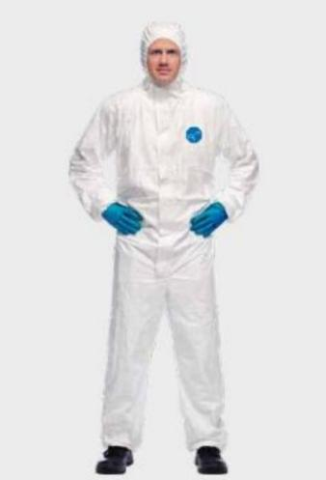 | Tyvek 400  Can be used for:  Handling general dust particles (e.g., heavy metal particles, asbestos) and paint spraying;  Protection against splashes of chemicals other than strong acids and bases (e.g., oils, sewage, fertilizers); prevention of biological hazards;  Handling animal waste;  Please note:  Cannot provide protection against ionizing radiation;  Cannot protect against cryogenic liquids and gases;  Cannot protect against hot liquids, steam, welding, or thermal radiation;  Not suitable for firefighting activities; has no flame-retardant properties.

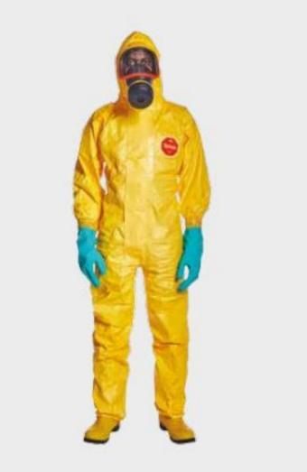 | Tychem 2000  Can be used for:  Providing protection against over 40 chemicals for more than 30 minutes;  Protection against splashes of general inorganic acids, bases, and salts;  Protection against biological hazards such as human blood, saliva, and feces;  Please note:  Cannot provide protection against ionizing radiation;  Cannot protect against cryogenic liquids and gases;  Cannot protect against hot liquids, steam, welding, or thermal radiation;  Not suitable for firefighting activities; has no flame-retardant properties.

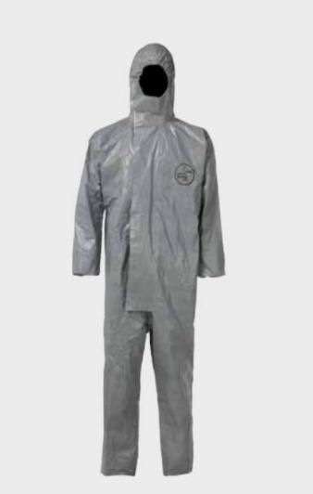 | Tychem 6000  Can be used for:  Providing protection against over 180 chemicals for more than 30 minutes;  Protection against splashes of inorganic acids, bases, salts, and organic solvents;  Protection against biological hazards such as human blood, saliva, and feces;  Please note:  Cannot provide protection against ionizing radiation;  Cannot protect against cryogenic liquids and gases;  Cannot protect against hot liquids, steam, welding, or thermal radiation;  Not suitable for firefighting activities; has no flame-retardant properties;
Types of Glove | Suitable for | Image
Nitrile chemical-resistant gloves | Suitable for solvents, oils, greases, and certain acids and bases | 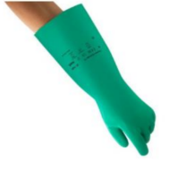
Neoprene gloves | Suitable for acids, bases, alcohols, fuels, peroxides, hydrocarbons, and phenols.  Not suitable for halogenated and aromatic hydrocarbons.  Suitable for most hazardous chemicals. | 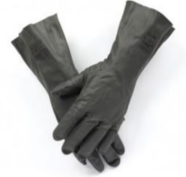
Butyl rubber gloves | Suitable for ketones and esters.  Not suitable for gasoline and aliphatic, aromatic, and halogenated hydrocarbons. | 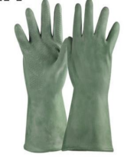
Laminate gloves | Suitable for most hazardous chemicals.  Poor fit; other rubber gloves that fit the hand snugly should be worn over the laminate gloves. | 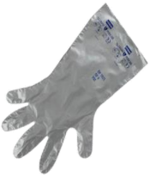

Types of Respiratory | Suitable for | Image
Half-face respirator | When properly fitted to the wearer and used correctly, is expected to reduce the concentration of airborne contaminants by a factor of 10 | 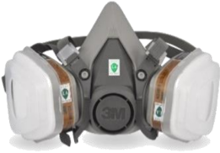
Full-face respirator | When properly fitted to the wearer and used correctly, is expected to reduce the concentration of airborne contaminants by a factor of 100 | 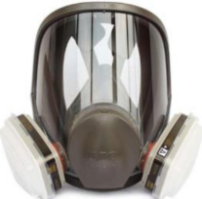
SCBA | Applicable scenarios:  The spilled chemical at the scene is unknown; or  The concentration of environmental contaminants has reached a value that is immediately dangerous to life or health; or  The oxygen concentration at the scene is below 18%; | 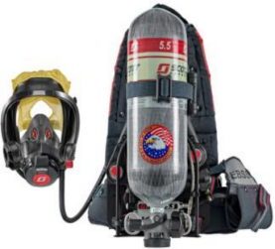

Appendix 3 Self-Inspection Checklist for Emergency Responders Prior to On-Site Response
Self-inspection items | Self-inspection confirmation content | Self-inspection confirmation result | Remarks
Self-inspection of emergency responders | Suffers from a disease that makes strenuous exercise inadvisable in the near term, or is in the recovery period of such a disease (e.g., heart disease, epilepsy, implanted cardiac pacemaker, still in recovery after surgery, etc.) | Yes/No
Self-inspection of emergency responders | Has received and passed SCBA use training (for scenarios where an SCBA is required) | Yes/No
Self-inspection of emergency responders | Has received and passed a fit test and selected a respirator that fits oneself (for scenarios where a half-facepiece or full-facepiece respirator is required) | Yes/No
Self-inspection of emergency responders | Has participated in on-site response training and hands-on drills | Yes/No
Self-inspection of emergency responders | Before the response, the emergency responder is emotionally stable, in normal physical condition, not overly anxious, able to concentrate during the on-site response, and confident in completing the following response workflow | Yes/No
Pre-response self-inspection of emergency supplies | On-site detection instruments such as the 4-in-1 gas detector and TVOC detector can be started up normally, batteries are fully charged, and the explosion-proof two-way radio works normally | Yes/No
Pre-response self-inspection of emergency supplies | The emergency supplies response kit cart or on-site response emergency supplies kit (including PPE, absorbent neutralizers, absorbent pads, absorbent pillows, hazardous waste collection buckets, warning signs, warning tape, brooms, dustpans, forceps, labels, explosion-proof portable axial safety fan, mobile power supply, door cards, door stops, etc.) is fully stocked | Yes/No | Different levels have different checklists for the contents of supplies and equipment.
Pre-response self-inspection of emergency supplies | The floor plan of the emergency response site (such as as-built drawings and the list of important equipment and facilities) is available | Yes/No
Pre-response  self-inspection of the emergency response procedure | First-hand information needed for entering the site has been obtained, such as the name of the spilled substance and its SDS, the quantity spilled, the specific location of the spill, whether there is an EV button on site, whether anyone is injured or trapped, the on-site liaison person and location, and any other matters worthy of attention | Yes/No
 | Effective communication and liaison have been established with the personnel or departments participating in or assisting the response (such as the Security Control Center), ensuring multi-department collaboration and that the emergency response procedure can be started up normally | Yes/No
 | Environmental measurement and safety assessment of the site have been conducted | Yes/No

